

**Bird training system**

**Software Requirement Specification**

– Ho Chi Minh city, June 2023 –

Record of changeS

|  |  |  |  |
| --- | --- | --- | --- |
| Date | A* M, D | In charge | Change Description |
| 24/6/2023 | A | Create new SRS | Create New Software reuqirement Specification |
|  |  |  |  |
|  |  |  |  |
|  |  |  |  |
|  |  |  |  |
|  |  |  |  |
|  |  |  |  |
|  |  |  |  |
|  |  |  |  |
|  |  |  |  |
|  |  |  |  |
|  |  |  |  |

*A - Added M - Modified D - Deleted

**Table of Contents**

I. Overview 5

1. Introduction 5

2. System Functions 6

3. Entity Relationship Diagram 11

II. Functional Requirements 15

1. Common Feature 15

a. Login 15

b. Logout 15

2. View and edit profile feature 16

a. View profile 16

b. Edit profile 17

3. Public feature 18

a. Home Page 18

b. About us 18

c. Web Blog List 19

d. Contact 20

e. Course 21

f. View Rating and comment 24

g. Enrol bird course: 25

h. View blog 26

i. Search blog 27

j. Rate blog 28

k. View top course of centre: 28

l. Introduction information of trainers: 30

m. View introduction about the centre: 30

n. View rating of courses: 31

o. View courses and its information: 32

p. View top courses of centre: 33

q. View blog: 33

r. Search blog: 34

s. View trainer’s information: 35

4. Admin Feature 35

a. Manage account. 35

5. Staff Feature 35

a. Manage course 35

b. Manage trainer 36

c. Manage forms 37

d. View dashboard (staff): 37

e. Manage invoice (staff): 38

6. Customer feature: 40

a. Function to give feedback about courses. 40

b. Function to process payments. 43

c. Fill form – Service type: Private Consultation 44

d. Function for checking bird status: 45

e. Function to track every module: 45

f. Function to fill enrolment form: 46

7. Trainer Feature 47

a. View courses are training: 47

b. View courses are training: 47

c. View information: 48

# I. Overview

General information about our project Bird Training System :

1. Project name: Bird Training System
2. Group name : Group 4
3. Software type : Website

## 1. Introduction

Today, more than ever, people are embracing the joy and wonder of owning birds as pets. Birds are intelligent, social creatures that bring beauty and charm to our lives. However, properly caring for and training birds can be a complex and challenging endeavour. That's where the Bird Training System comes in.Our System is a comprehensive online platform designed to facilitate the training and education of bird and bird owners. The system enables users to purchase various courses, including in-person workshops, online courses, consultations, and specialized training programs. Users have the option to send their birds to trainers for personalized training or engage in self-paced online learning. The system also provides a feature that allows users to track the progress of their birds' training through the website.

.

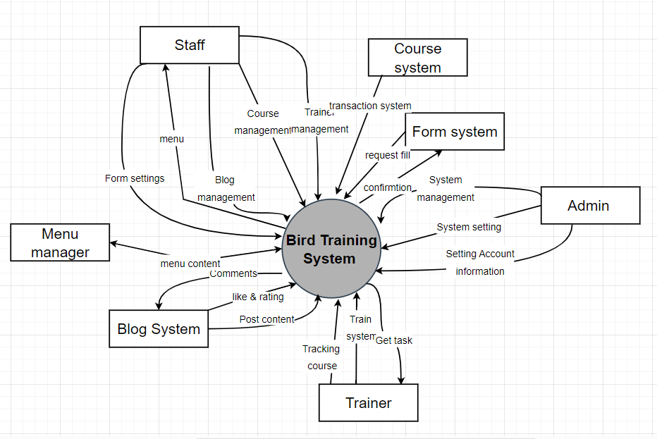>>

## 2. System Functions

#### a. Screen Flow

*[This part shows the system screens and the relationship among screens. You can draw the Screens Flow for the system in the form of diagram as below]*

#### b. Screen Details

|  |  |  |  |
| --- | --- | --- | --- |
| **#** | **Feature** | **Screen** | **Description** |
| 1 | Public | Homepage | This is the landing page of the Bird Training System accessible to all users. This screen contain  Brief info, Top course, 4 services , Top trainer , Feedback Trainer. |
| 2 | Customer | Booked Service | This screen displays the services booked by the customer(Workshop – Bird Course – online Training – Private consultation) |
| 3 | Customer | Workshop | This screen provides access to workshops the customer has purchased. |
| 4 | Customer | Bird course | This screen allows customers to access the bird courses they have purchased |
| 5 | Customer | Tracking Page | This screen allows customers to access the bird courses they have purchased |
| 6 | Public | Course for bird in center | This screen provides information about the courses offered at the bird training center |
| 7 | Public | Workshop | This screen displays information about workshops held at the bird training center |
| 8 | Public | Detail information | This screen provides detailed information about the bird training system and its offerings |
| 9 | Staff | Staff | This screen shows the service overall of bird center. There are 4 services in this screen (workshop, private consultation, online course, bird course). |
| 10 | Staff | Course list _ staff | Show all the courses of the center. |
| 11 | Staff | CRUD course | Staff can update information about the course in this screen. |
|  |  |  |  |
| 12 | Staff | Add new course | This screen will show a form for staff create a new course. |
| 13 | Staff | Form list pending | This screen shows the list of form which pay offline in waiting list for staff browse. |
| 14 | Staff | Form detail | This screen shows the detail information of form |
| 15 | Staff | Form list processing | This screen shows the list of private consultation form which are waiting staff for browsing. |
| 16 | Staff | Order list | This screen shows the list of orders. |
| 17 | Common | Notification |  |
| 18 | Public | About us | -Show navigation bar: Home, About us, Service, Blog, Contact  -Show details of our company mission, our trainer team and our results |
| 19 | Admin | Admin | -Show navigation bar: Account list |
| 20 | Admin | Account list | -Show a table containing all accounts and info includes email, username, role, status  -Display action button: view detail |
| 21 | Admin | Account detail information | -Show a form which includes email, username, role, status  -Display action button: edit, delete account |
| 22 | Staff | Blog list | -Show a table containing all blogs and info includes blog name, author, date created  -Display action button: view detail, delete blog |
| 23 | Staff | CRUD blog | -Show a form containing blog info as inputs that can be edited  -Display action button: submit |
| 24 | Staff | Add blog | -Show a form containing fields: blog name, author, content  -Display action button: submit |
| 25 | Trainer | Bird Course Tracking List | Show information of bird course: Bird name, Bird type, Training status, Course name, traning duration. Show a set status button: trainer can choose 3 status: Check-in, In-training, Check-out and passed down to database |
| 26 | Trainer | Workshop Tracking List | Show information of workshop: workshop name, , duration. |
| 27 | Trainer | Private Consultation Tracking List | Show information of private consultation: customer information: name, phone, address, request message |
| 28 | Public | Log-in | This screen displays username and password for user to input. If user is authorized, they will gain access to the system |
| 29 | Public | Sign up | This screen displays username, password, full name, phone number for user to input. Then will create a new account |
| 30 | Customer | Forgot password | This screen displays a username for user to input, if the username exists on database, a reset code will be sent to user via email |
| 31 | Customer | Create new password | This screen displays 2 box password and confirm password. |
| 32 | Public | Blog | This screen displays list of blogs |
| 33 | Public | Blog detail | This screen displays the blog in detail |
| 34 | Customer | Workshop | This screen displays a list of workshops that user can pick with cleared information about the workshops and registration deadlines |
| 35 | Customer | Course online | This screen displays a list of online courses that user can choose to learn |
| 36 | Customer | Private consultation | This screen displays a variety of choices that user can choose to write a inquiry for private consultation |
| 37 | Customer | Bird course | This screen shows a selection of course specified for only birds that user can pick to train their birds |
| 38 | Customer | Detail workshop | This screen shows a detailed information of the workshop that user have just picked with workshop description |
| 39 | Customer | Detail Course online | This screen shows a detailed information of the online course that user have just picked with online course description |
| 40 | Customer | Payment page | This screen shows below every detail page if user wants to perform a payment on that item |
| 41 | Customer | Detail Bird course | This screen shows a detailed information of the bird course that user have just picked with bird course description |

#### c. User Authorization

*[Provide the system roles authorization to the system features (down to screens, and event to the screen activities if applicable) in the table form as below – replace Role1, Role2,… with the specific system user role names]*

|  |  |  |  |  |  |
| --- | --- | --- | --- | --- | --- |
| **Screen** | **Guest** | **Customer** | **Trainer** | **Staff** | **Admin** |
| Homepage | X | X | X | X | X |
| Booked Service |  | X |  |  |  |
| Workshop |  | X |  |  |  |
| Bird course |  | X |  |  |  |
| Tracking Page |  | X |  |  |  |
| Course for bird in center | X | X |  |  |  |
| Workshop | X | X |  |  |  |
| Detail information | X | X |  |  |  |
| Staff |  |  |  | X |  |
| Course list _ staff |  |  |  | X |  |
| CRUD course |  |  |  | X |  |
| Add new course |  |  |  | X |  |
| Form list pending |  |  |  | X |  |
| Form detail |  |  |  | X |  |
| Form list processing |  |  |  | X |  |
| Order list |  |  |  | X |  |
| About us | X | X | X | X | X |
| Admin | X |  |  |  |  |
| Account list | X |  |  |  |  |
| Query All Accounts | X |  |  |  |  |
| Account detail information | X |  |  |  |  |
| Query Accounts Info | X |  |  |  |  |
| Update Account Info | X |  |  |  |  |
| Delete Account | X |  |  |  |  |
| Blog list |  | X |  |  |  |
| Query All Blogs |  | X |  |  |  |
| Delete Blog |  | X |  |  |  |
| CRUD blog |  | X |  |  |  |
| Query Blog Details |  | X |  |  |  |
| Update Blog Details |  | X |  |  |  |
| Add blog |  | X |  |  |  |
| Add new blog |  | X |  |  |  |
| Bird Course Tracking List |  |  | X |  |  |
| Workshop Tracking List |  |  | X |  |  |
| Private Consultation Tracking List |  |  | X |  |  |
| Log-in | x |  |  |  |  |
| Sign up | x |  |  |  |  |
| Forgot password |  | x | x | x | x |
| Create new password |  | x | x | x | x |
| Blog | x | x | x | x |  |
| Blog detail | x | x | x | x |  |
| Workshop |  | x |  |  |  |
| Bird course |  | x |  |  |  |
| Private consultant |  | x |  |  |  |
| Online course |  | x |  |  |  |
| Detail service page |  | x |  |  |  |
| Payment |  | x |  |  |  |

In which:

|  |  |
| --- | --- |
| Role | Description |
| Guest | A person using the system without logging |
| Customer | A person using the system with logging to enrol course |
| Trainer | A person using the system  to do task training and track training progress |
| Staff | A person using the system as  distributor  to manage the operating of training school system |
| Admin | A person using the system as a distributor . The purpose is to manage  organise accounts |

#### d. Non-Screen Functions

*[Provide the descriptions for the non-screen system functions, i.e batch/cron job, service, API, etc.]*

|  |  |  |  |
| --- | --- | --- | --- |
| **#** | **Feature** | **System Function** | **Description** |
| 1 | Common | Sign out | Users sign out of the system |
| 2 | Common | User Authorization | This is the authorization mechanism in the system, |
| 3 | Common | Booking | Users have to login if they want to book a course. On the course detail screen, if user have logged in already, they will move to payment, else they will move to login page. |

## 3. Entity Relationship Diagram

**Entities Description**

**Role: Hoang Kim Nam**

|  |  |  |
| --- | --- | --- |
| **#** | **Entity** | **Description** |
| 1 | User | The User entity represents an individual who interacts with a system or platform. It typically refers to a person who has registered or created an account within the system. Users can access various features, functionalities, and personalized settings based on their account information  Attribute:   * ID: : A unique identifier assigned to each user within the system. * Username: The chosen name or handle used by the user to identify themselves within the system * Password: A secure and confidential authentication credential used to verify the user's identity. * Role: Specifies the level of access or permissions granted to the user based on their role within the system (Admin,Customer, Staff, Trainer ). |
| 2 | Course | Description: The Course entity represents the training programs offered by a Bird Training Center. These courses are designed to teach bird-related skills and knowledge to customers:  Attributes :   * CourseID : A unique identifier assigned to each course within the system. * Trainer_ID: An identifier linking the course to the assigned trainer or instructor * Staff_ID: An identifier linking the course to the staff member responsible for managing it. * Course Description: A brief summary or overview describing the content, objectives, and scope of the course * Category: Specifies the format of the course, such as workshops, private consultations, or online lessons.  1. Private Consultation (Entity: Appointment) 2. Workshop ( Entity: Attendance) 3. Bird Course ( Entity :Booking) 4. Course Online( Entity: CourseBuy)  * Title: The name or title of the course that identifies it distinctively. * Price: The cost associated with enrolling in the course. |
| 3 | CourseImg | Description: The CourseImg entity represents the images associated with a course in the system. It allows for storing and linking images to a specific course:  Attributes:   * ID: A unique identifier assigned to each course image within the system. * A reference to the Course entity, linking the image to a specific course using the Course's CourseID attribute. * The actual images associated with the course( 1 course has 1 or more images) |
| 4 | Payment method | The payment ID and method attributes provide key information about a payment transaction, allowing businesses or systems to identify, record, and process payments accurately.   * Payment ID: The payment ID is a unique identifier assigned to a specific payment transaction.   Method: The method attribute represents the specific payment method used for a transaction. |
| 5 | Meal | * consultation_id: This column represents the unique identifier for an appointment or consultation.   trainer_id: This column stores the identifier of the trainer associated with the appointment.  customer_id: This column stores the identifier of the customer or client who booked the appointment.  date: The date column represents the date of the appointment.  amount: This column stores the payment amount for the appointment.  payment_id: The payment_id column represents the unique identifier associated with the payment for the appointment.  note: This column allows for additional notes or comments related to the appointment.  address: The address column stores the appointment location or address.  type: The type of column represents the type of appointment, such as a specific service or category.  present_price: This column stores the price associated with the appointment.  Status: The Status column represents the status of the appointment, indicating its current state or progress.  Tracking: The Tracking column stores tracking information related to the appointment.  Request_trainer_id: This column represents the identifier of a requested trainer for the appointment. |
| 6 | Meal Subscription | course_id: This column represents the identifier of the course that was purchased.  customer_id: This column stores the identifier of the customer or client who made the course purchase.  date: The date column represents the date of the course purchase.  amount: This column stores the payment amount for the course purchase.  payment_id: The payment_id column represents the unique identifier associated with the payment for the course purchase. |
| 7 | workshopTraining | workshop_id, course_id, trainer_id |
| 8 | Feedbacks | Id, customer_id, course_id, rating, comment |
| 9 | attendance | workshop_id, customer_id, dateCheck, amount, payment_id |
| 10 | Booking | Bird_id, name, type |
| 11 | Bird | Customer_id, user_id, Fullname, Contact, img |
| 12 | Customer | Trainer_id, course_id, customer_id, bird_id, start_date, end_date, status, amount |
| 13 | skill | This entity contains all of the skill that applied to Trainer and Course.  Attribute:   * skill_id: primary key   name: describe the skill |
| 14 | skillTrainer | This entity is a M-M relationship between the skill entity and trainer entity. A trainer has many skills and a skill can belong to many trainers  Attribute:   * skill_id: reference to skill_id in skill entity   trainer_id : refrerence to trainer_id in trainer entity |
| 15 | skillCourse | This entity is a M-M relationship between the skill entity and course entity. A course has many skills and a skill can belong to many courses  Attribute:   * skill_id: reference to skill_id in skill entity   course_id : refrerence to course_id in trainer entity |
| 16 | Trainer | The Trainer entity represents individuals who have expertise and experience in bird training. They are professionals or enthusiasts who possess the knowledge and skills required to train birds effectively. Trainers play a crucial role in imparting training techniques, providing guidance, and sharing their expertise with bird owners, enthusiasts, or other individuals seeking to train birds.  - Attributes:  . trainer_id: a unique identifier assigned to each trainer in the database  . user_id: a unique identifier associated with the user account of the trainer  . fullName: full name of the trainer |
| 17 | Blog | The Blog entity represents individual blog posts created by staff members or contributors. It serves as a platform for sharing articles, news, opinions, or other types of written content related to a specific topic or subject matter.  - Attributes:  . id: A unique identifier assigned to each blog post in the database.  . staff_id: An identifier associated with the staff member or contributor who authored the blog post.  . date: The date when the blog post was published or last updated.  . content: The textual content of the blog post, which includes the main body of the article or post. |
| 18 | BlogIMG | The BlogIMG entity represents images associated with a blog post. It is used to store and link images that are related to specific blog posts.  - Attributes:  . blog_id: A foreign key referencing the ID of the blog post to which the image belongs. It establishes the association between the blog post and the image.  . image: The actual image file or a reference to the image file stored in the database or a designated file storage system. |

# II. Functional Requirements

## 1. Common Feature

### a. Login

* Function trigger: This function is triggered when the user clicks Sign on the Navigation bar
* Function description: User sign in into the system
* Screen layout: mockup prototype of the screen, sample below is for Sign in screen:

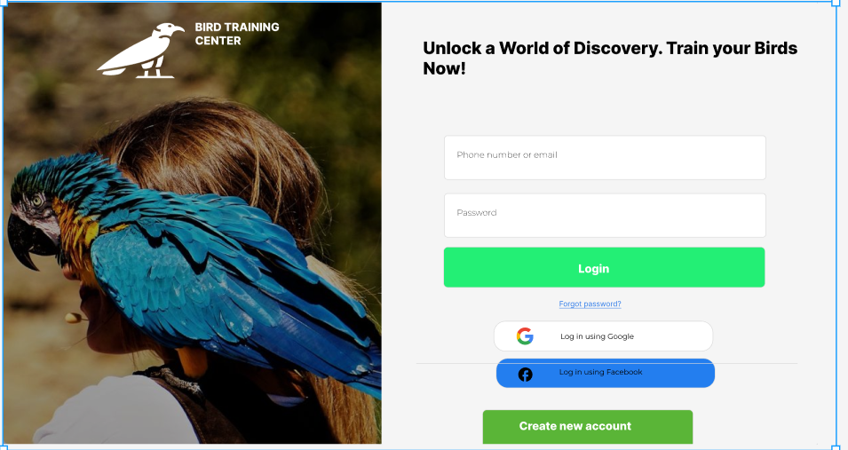

* Function Details: When a guest user is not logged in and visits the homepage screen, they will see a "Sign In" button. If the user clicks on any function that requires them to be logged in, they will be directed to the login page. After successfully logging in, the "Sign In" button in the navigation bar will be replaced with the user's avatar and will include a "Logout" option.

### b. Logout

* Function trigger: The user selects the "Logout" option from the navigation bar or a designated logout button
* Function description: This use case allows users to log out from the bird training center system
* Screen layout: mockup prototype of the screen, sample below is for Logout screen

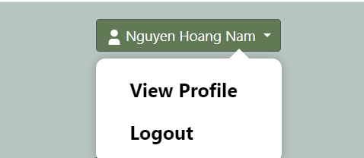

* Function Details: Customers navigates to their account ddashboard and selects option “Logout” . When the click Logout , the user is presented with a confirmation message indicating a successful logout. The user's access to restricted or authenticated features is revoked . About system , The system may perform additional actions, such as clearing any session-related data or updating the user's status as logged out

…

## 2. View and edit profile feature

### a. View profile

* Function trigger: This function is triggered when the user clicks on their profile avatar the Navigation bar
* Function description: This use case allows customers to view their profile information on the website
* Screen layout: mockup prototype of the screen, sample below is for Sign in screen:

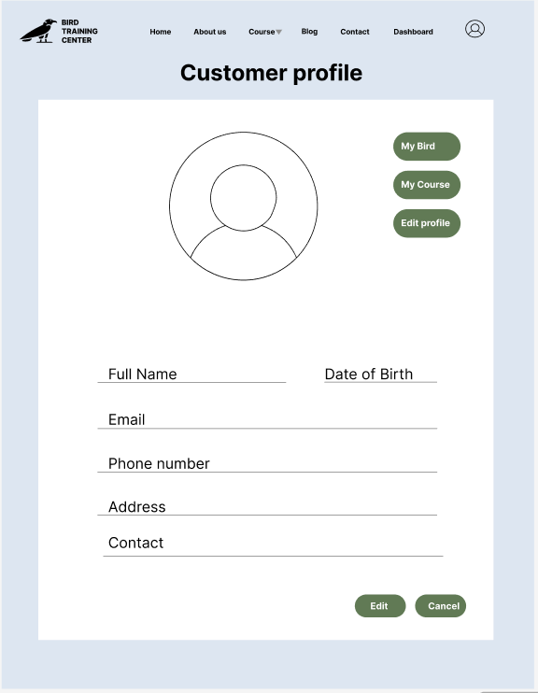

* Function Details : Customers can navigate to their account dashboard or profile section on the website to view various information related to their activities on the system. This includes their basic profile details, courses they are currently enrolled in, and their order history. The system allows customers to access any relevant information that has been set up for their account.

### b. Edit profile

* Function trigger: This function is triggered when the user clicks “Edit profile” on the menu of the Profile Customer page.
* Function description: Customer edits information of the profile
* Screen layout: mockup prototype of the screen, sample below is for Sign in screen:
* 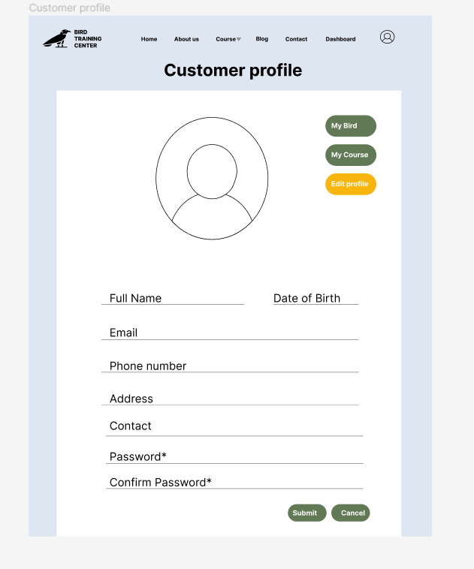
* Function Details: When customers choose to edit their profile, the system will display a form containing information that can be modified. This includes fields such as full name, phone number, email, and profile picture. The customer can make changes to the desired fields and submit the modifications. The system then validates the updated information and saves it in the database. Finally, a success message is displayed to confirm that the profile changes have been saved successfully.

## 3. Public feature

### a. Home Page

* Function trigger: This function is triggered when the user visits the website or the system homepage
* Function description: Users see briefs about introduction, top course , 4 services , top 5 trainers, top feedbacks, the system's specialities.
* Screen layout: mockup prototype of the screen, sample below is for Sign in screen:



* Function Details : When users access the system, the homepage will appear and show information about the system. And Form the home page , the user can naviage all of function in the wedsite.

### b. About us

* Function trigger: This function is triggered when the user visits the function “About us “ screen on thje navigation bar
* Function description: Users see briefs about introduction, top course , 4 services , top 5 trainers, top feedbacks, the system's specialities.
* Screen layout: mockup prototype of the screen, sample below is for Sign in screen:
* 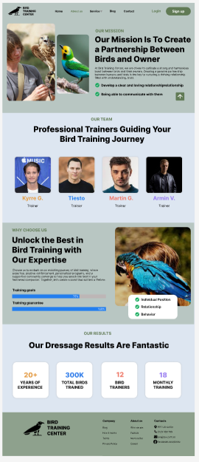
* Function Details : When usersclick on the About us on the navigation bar , the “About us“ screen will appear and show information about the system.

### c. Web Blog List

* Function trigger: This function is triggered when the user click “Blogs” on the navigation Bar
* Function description: The function will show aa list of blogs
* Screen layout: mockup prototype of the screen, sample below is for Sign in screen:

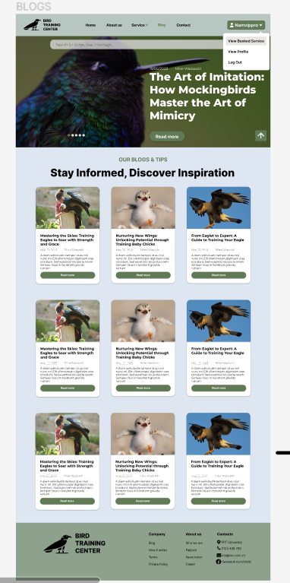

* Function Details : The user clicks on “Blog” button in the navigation bar

+ Each of blog card have:Thumbnail of blog, Title of blog, Public date , Director ,Author , Date created , Some introduction about the blog

+ On the top of list blogs has A search button ( by category , by name )

+ On the top , has a decoration picture

### d. Contact

* Function trigger: This function is triggered when the user click the contact on the naviagtion bar
* Function description: Users see a form that have some following information that system set , that user can fill and submit foirm for conatcting
* Screen layout: mockup prototype of the screen, sample below is for Sign in screen:

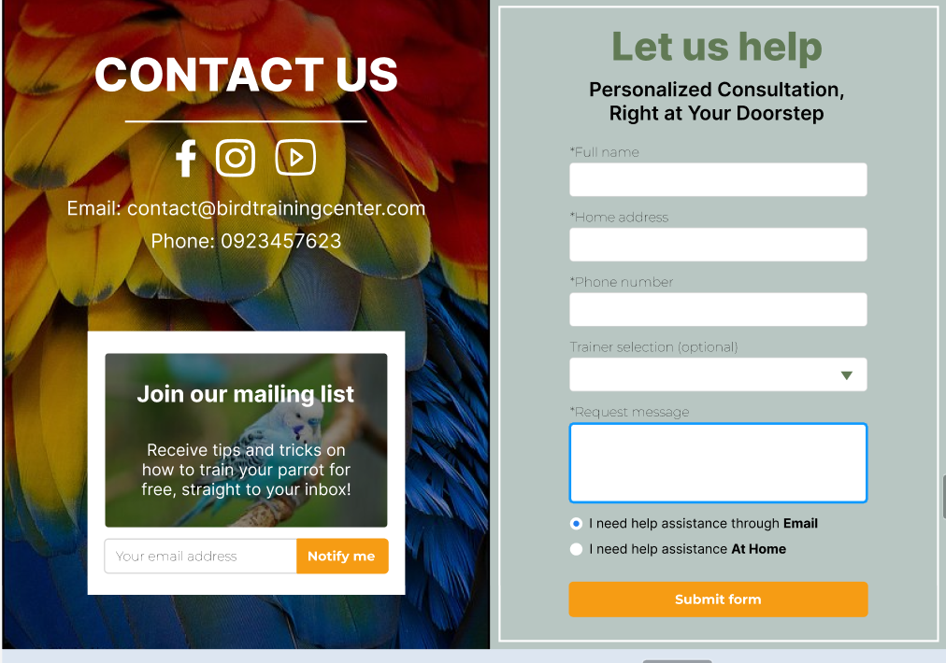

* Function Details : The user click on the “Contact” on the navigation bar
* Show a form that contain detail( Fullname , email , bird type , bird name , trainer ,address, date , trainer , note )
* The right sider is a price ture with email box for user can conatct with email

### e. Course

*I. Bird Course*

* Function trigger: This function is triggered when the user click the course on the naviagtion bar
* Function description: Users see a list of course that have some following information that system set , that user can click on each course to show detail of course and lead to book a course
* Screen layout: mockup prototype of the screen, sample below is for Bird course screen:

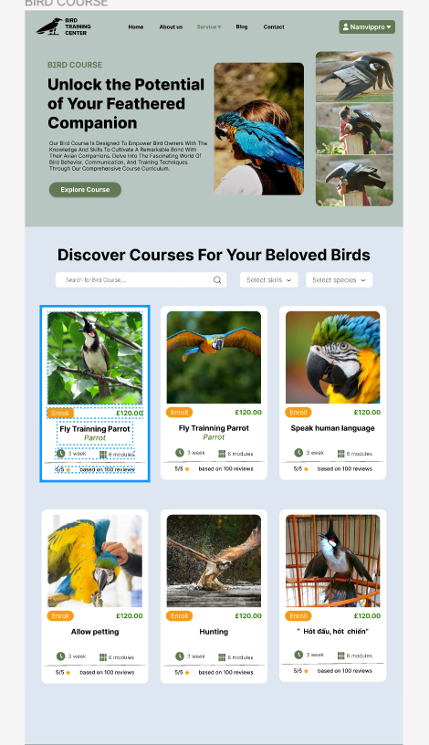 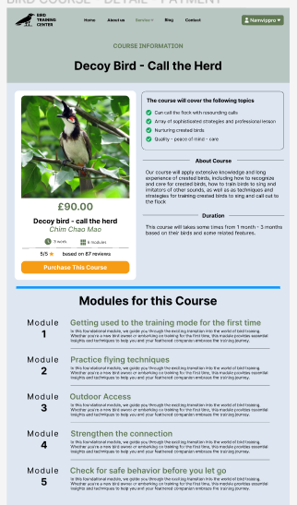

* Function Details: When the user clicks on "Services" and then selects "Bird Course" from the navigation bar:
* The system will display a list of courses in a card format, each containing the following information: thumbnail image, title, duration, modules, price, and an "Enroll" button.
* The top sidebar has a layout with brief info – Thumbnail
* The top sidebar will feature a search box where customers can search for specific courses they are interested in.
* When a user clicks on a course card, the system will navigate to the screen displaying detailed information about the selected course.

*2. Workshop*

* Function trigger: This function is triggered when the user click the servise and choose “Workshop” on the naviagtion bar
* Function description: Users see a list of course that have some following information that system set , that user can click on each course to show detail of course and lead to book a course
* Screen layout: mockup prototype of the screen, sample below is for Workshop screen:

 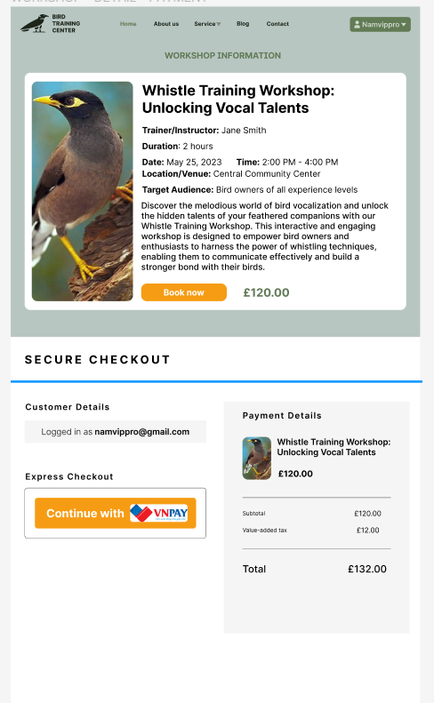

* Function Details: When the user clicks on "Services" and then selects "Workshop" from the navigation bar:
* The system will display a list of courses in a card format, each containing the following information: thumbnail image, title, duration, modules, price, and an "Enroll" button.
* The top sidebar has a layout with brief info – Thumbnail
* The top sidebar will feature a search box where customers can search for specific courses they are interested in.
* When a user clicks on a course card, the system will navigate to the screen displaying detailed information about the selected course.

*3.Online Course*

* Function trigger: This function is triggered when the user click the servise and choose “Online” on the naviagtion bar
* Function description: Users see a list of course that have some following information that system set , that user can click on each course to show detail of course and lead to book a course
* Screen layout: mockup prototype of the screen, sample below is for Workshop screen:

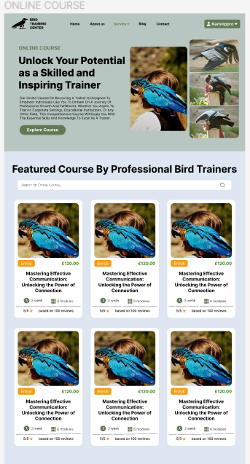 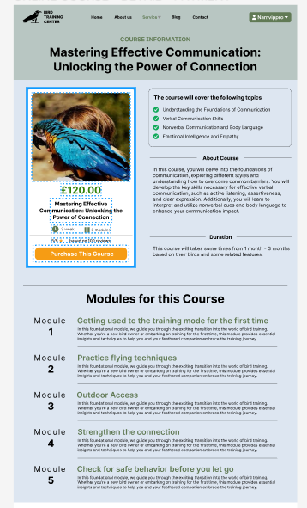

* Function Details: When the user clicks on "Services" and then selects “Online Course" from the navigation bar:
* The system will display a list of courses in a card format, each containing the following information: thumbnail image, title, duration, modules, price, and an "Enroll" button.
* The top sidebar has a layout with brief info – Thumbnail

The top sidebar will feature a search box where customers can search for specific courses they are interested in.

*4.Private Consultation*

* Function trigger: This function is triggered when the user click the servise and choose “Online” on the naviagtion bar
* Function description: Users see a list of course that have some following information that system set , that user can click on each course to show detail of course and lead to book a course
* Screen layout: mockup prototype of the screen, sample below is for Workshop screen:

 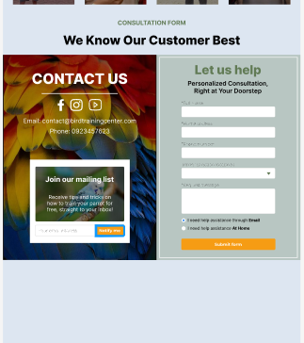

* Function Details: When the user clicks on "Services" and then selects “Private consultation" from the navigation bar:
* The system will display a list of courses in a card format, each containing the following information: Brief info , Thumbnail , Trainer , Contact us to book
* The top sidebar has a layout with brief info – Thumbnail
* The top sidebar will feature a search box where customers can search for specific courses they are interested in.
* The below bar has contact form to book a private consultation

### f. View Rating and comment

* Function trigger: When a user wants to view the ratings and comments for a specific item or service
* Function description: his functionality allows users to see the ratings and comments provided by other customers for a particular item or service. It provides valuable feedback and helps users make informed decisions before enrolling or participating.:
* Screen layout: mockup prototype of the screen, sample below is for Workshop screen:

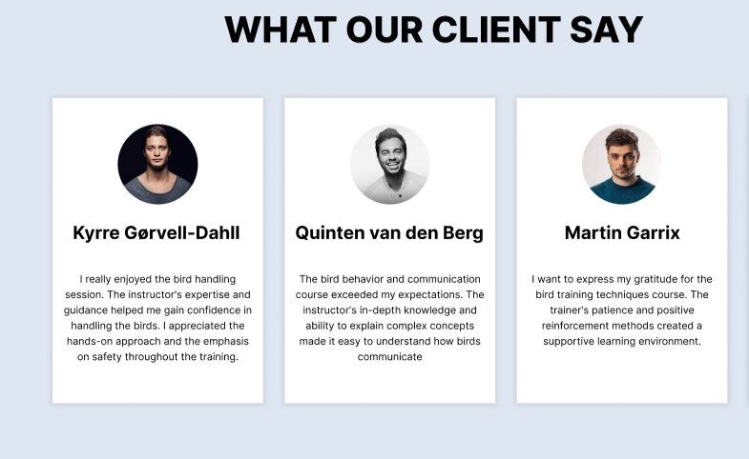

* Function description :
* The screen displays the title of the workshop.
* The average rating for the workshop is shown, typically represented as a numerical value out of 5.
* The ratings and comments from previous customers are listed, displaying the customer's name, rating value, and comment.
* Customers can scroll through multiple ratings and comments.
* There is an option for users to add their own rating and comment.
* The layout and design can be customized based on the overall visual style of the Bird Training System.

### g. Enrol bird course:

* Function trigger: This function is triggered when the user click “Enroll” on the course they want to enroll
* Function description: Allow user to enroll the course
* Screen layout: mockup prototype of the screen, sample below is for Enroll course screen

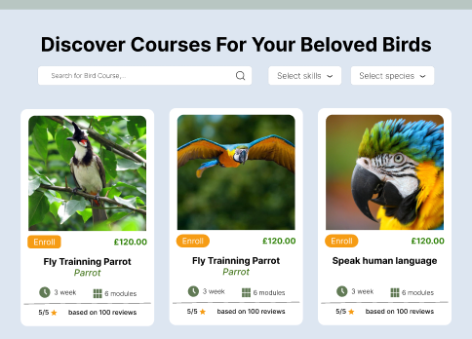

* Function Details: The user can enroll into the course they want.

### h. View blog

* Function trigger: This function is triggered when the user click “Read more” on the blog they want to view from blogs page
* Function description: Allow user to view the blog
* A picture containing dog, text, mammal, screenshot

  Description automatically generatedScreen layout: mockup prototype of the screen, sample below is for Blogs and Blog detail screen

* Function Details: The user can view details of the blog they want.

### i. Search blog

* Function trigger: This function is triggered when the user click search bar on top of blogs page.
* Function description: Allow user to search for a blog using keywords
* Screen layout: mockup prototype of the screen, sample below is for Blogs screen

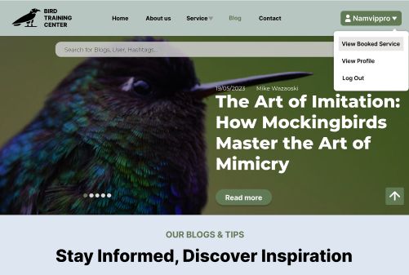

* Function Details: The user can search for the blog they want.

### j. Rate blog

* Function trigger: This function is triggered when the user click up or down arrow next to blog content in blog detail page.
* Function description: Allow user to rate a blog.
* Screen layout: mockup prototype of the screen, sample below is for Blogs screen

* Function Details: The user can up-vote or down-vote the blog.

### k. View top course of centre:

Function trigger: This function is triggered when the user visits the website or the system homepage.

● Function description:   
 This function displays a list of top courses on the homepage. It provides users with an overview of the available courses and allows them to browse through the options.

● Screen layout: simulated prototype of the screen, the sample below is for the home screen

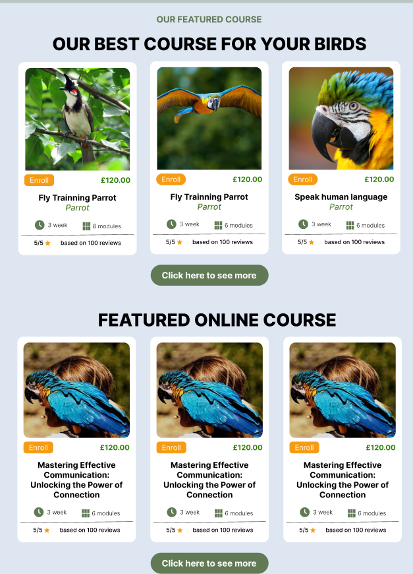

● Function Details:

The function retrieves data about the top courses from the database or a designated source.

It presents the course information such as course name, duration, rating.

Users can click on a course to access its detailed page for more information or to enrol.

### l. Introduction information of trainers:

Function Trigger: User navigates to the "About Us" page.

● Function Description: This function provides information about the trainers associated with the bird center. It showcases their name, and images,

● Screen Layout:

● Function Details:

The function retrieves trainer information from the database or a designated source.

It presents the trainer profiles with details such as name, image.

### m. View introduction about the centre:

* Function trigger: This function is triggered when user clicks on the About us button
* Function description: This function shows user brief information about the Bird Training Center
* Screen layout:
* A screenshot of a website

  Description automatically generated with low confidence
* Function detail: When user is concerned about the Centre, they can click on the “About us” button, then they will be redirected to the About us page. From there, they can learn about our Training centre with various of information.

### n. View rating of courses:

* Function trigger: This function triggered when user navigate to the “Bird course” page.
* Function description: This function show rating (star out of 5) of courses.
* Screen layout:

* Function detail: When user navigate to “Bird course” page, they will see course’s information and the rating (represented as the star) that has been rated by former customers attending that course.

### o. View courses and its information:

* Function trigger: This function is triggered when they clicked the button “Enroll” in “Bird course” page
* Function description: This function shows the course’s detail
* Screen layout:

Function detail: In the detail page, guest can see the bird course’s image, name, price, rating, module for that course.

### p. View top courses of centre:

* Function trigger: This function is triggered when guest want to see top courses
* Function description: This function will display top 3 courses that has the highest rating
* Screen layout:

Function detail: When guest is in the homepage, they will see “Top course” section, this will display the 3 courses having highest rating.

### q. View blog:

* Function trigger: This function will be triggered when customer clicks on “Blog” button
* Function description: This function will display a list of blog with the latest update order
* Screen layout:

* Function detail: In this function, customer can see a list of blog and they can click on “view” button to view the blog in detail

### r. Search blog:

* Function trigger: This function is triggered when guest want to search for a blog.
* Function description: This function allow guest to search for a blog by a keyword.
* Screen layout:

* Function detail: When user input a keyword/ name, this function will find if any blog contains that keyword. If yes, it will display on the screen, else display none.

### s. View trainer’s information:

* Function trigger: This function is triggered when customer click on “About us” button
* Function description: This function displays a list of trainers.
* Screen layout:

* Function detail: In “About us” page, there is a section displays our trainers, it will show every trainer following with their image, name.

## 4. Admin Feature

### a. Manage account.

* Function trigger: This function is triggered when the user click “Manage account” in the navbar
* Function description: Allow user to update, delete, set role
* Screen layout: mockup prototype of the screen, sample below is for Enroll course screen
* Function Details: The user can manage account.

## 5. Staff Feature

### a. Manage course

* Function trigger: This function is triggered when the user click “Manage course” in the navbar
* Function description: Allow user to create course, update course, delete course
* Screen layout: mockup prototype of the screen, sample below is for Enroll course screen

* Function Details: The user can manage course.

### b. Manage trainer

* Function trigger: This function is triggered when the user click “Set trainer” in pending form
* Function description: Allow user to set trainer for the pending form.
* Screen layout: mockup prototype of the screen, sample below is for Form list private consultant screen

* Function Details: The user can set trainer for pending form.

### c. Manage forms

* Function trigger: this function is triggered when staff click on approve or deny on form’s detail screen.
* Function description: Staff approve for valid form for customer want to enrol for private consultation.
* Screen layout:

* Function detail: When a customer enrols in private consultation service, they must fill thee form for this service. This form will be browsed by staff who can approve or deny form.

### d. View dashboard (staff):

* Function trigger: This function is triggered when staff click on “view dashboard”.
* Function description: Staff can view the revenue statistic of centre.
* Screen layout:

* Function details: When users click on view dashboard, they will be redirected to dashboard screen. The revenue of centre is displayed on the chart following week, months. There also be table show of top of service in my centre.

### e. Manage invoice (staff):

* Function trigger: This function is triggered when staff click on “view order list”.
* Function description: Function will update status of course which is paid by customer through offline method.
* Screen layout:

* Function detail: Staff can view all the course which are paid by offline method. In this screen, staff also can update status “finished” on the order which have already paid by customers.

## 6. Customer feature:

### a. Function to give feedback about courses.

Function Trigger: User visits the course detail page.

● Function Description: This function enables users to provide feedback and reviews about a particular course they have attended or are interested in. It allows them to share their thoughts, rate the course, and provide comments to help future learners make informed decisions.

● Screen Layout: simulated prototype of the screen, the sample below is for the home screen

Bird Course:

Online Course

● Function Details:

Users can access the feedback function through a designated area on the course detail page.

The function includes a form where users can enter their feedback, ratings, and comments.

Upon submission, the feedback is stored in the database or a designated storage system for future reference.

The system may also include functionality to moderate and manage the feedback, such as flagging inappropriate content or allowing instructors to respond.

### b. Function to process payments.

Function Trigger: User selects the payment option when checkout.

● Function Description: This function facilitates the payment process for users who want to pay for service. It provides both offline and online payment options to accommodate different preferences.

● Screen Layout:

● Function Details:

Online Payment (VNPAY):

- Users can select the online payment option using VNPAY, an online payment gateway.

- The function may redirect users to the VNPAY payment page, where they can securely complete the payment transaction.

- Once the payment is successfully processed, the function updates the user's enrollment status and provides confirmation.

### c. Fill form – Service type: Private Consultation

.Function trigger: This function is triggered when user clicks on “Contact us to book” and it will redirect user to input form

. Function description: The "Filling consultation forms" function allows users to submit their consultation requests by filling out the required forms. This feature facilitates communication between users and the staff, enabling users to provide relevant information and details about their consultation needs.

Screen layout:

Function detail: User inputs required information in the following form based on their requirement. Form represent a field for user to fill in. Then the system checks the validation of these inputted information whether it is accurate. Once the user has completed filling in the form, they can submit the form using submit form button.

….

### d. Function for checking bird status:

. Function trigger: This function triggers when user clicks on “View Booked Course” and choose “Bird Course” on navigation bar

. Function description: This function allows user to keep track on their birds learning progress through 3 stages of status: check-in, in-progress, check-out.

Screen layout:

. Function detail (view only): This function allow user to keep track on their bird through 3 different stages: check-in, in-progress, check-out

### e. Function to track every module:

. Function trigger: This function triggers when user clicks on “View Booked Service” and choose available service

. Function description: The "Course Tracking" function allows users to keep track of the courses they are currently learning or have completed. This feature provides users with a convenient way to monitor their progress, access course materials, and stay organized throughout their learning journey.

Screen layout:

Function details: This function allow user to track their current process through different service such as bird course, online course, workshops with a “To course” button to view course progress detail they are learning.

### f. Function to fill enrolment form:

. Funtion trigger: this function triggers when user clicks on any related form that requires information details

. Function description: The "Fill Enrollment Form" function enables users to provide their information and enroll in a specific course. This function simplifies the enrollment process by guiding users through a form where they can enter their details accurately and efficiently.

. Screen layout:

. Function details: The user can select the course they wish to enroll in from a list of available course through a search functionality. Then the system represents an enrollment form to the user, specify to the selected course. The form may include fields for personal information, contact details or any other relevant information ( address, type of bird, general index)

## 7. Trainer Feature

### a. View courses are training:

* Function trigger: This function is triggered when trainer clicks show my working.
* Function description: Collect all of courses of this trainer and show out on screen.
* Screen layout:
* Function details: Trainer can view all the course that they are teaching on this screen. After trainer click “complete course”, these courses will not show on “teaching list” anymore.

### b. View courses are training:

* Function trigger: This function is triggered when trainer click on the course on “teaching list” of trainers.
* Function description: Trainer will change status “complete” on each module of course when he finishes. This also be updated on customer’s side.
* Screen layout:

* Function detail: Trainer will change the type of status of course for customers can follow each step of the course of centre.

### c. View information:

. Function trigger: this function triggers when trainer clicks on a random course detail through a “Detail” button

. Function description: The "View Course Information" function allows trainers to access and review the details and materials related to the courses they are assigned to train. It provides trainers with a comprehensive overview of the course content, schedule, resources, and any other relevant information necessary for effective training delivery.

. Screen layout:

. Function detail: Upon accessing the "View Course Information" function, the system presents the trainer with a list of courses they are assigned to train or allows them to search for a specific course. The system displays a summary of the selected course, including the course title, description, objectives, and target audience. This overview provides trainers with a quick understanding of the course's purpose and scope.